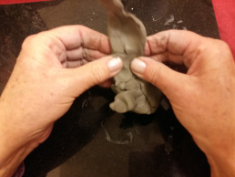
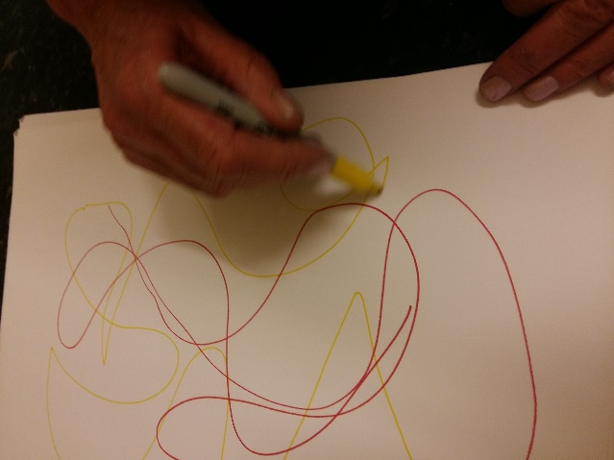
Art Therapy Workshop
Reflection – 19/12/18
I am very happy with the results from my workshops, I am pleased with the diversity and sense of self each individuals file contains. I believe I achieved what I set out to: generate a range of expressive automatic outsider response works, the fact these pieces were produced through states of mental disorder adds key contextual research to my work, I feel this responds well to all aspects of my project, theory, experimental/practical and primary research.
The works generated are great expressive pieces that contrast sense of identity in one another, I feel these pieces in themselves are perfect products of the mind as they were inspired and automatic, almost childlike and I feel when we can find the child within, we are edging closer to the unconscious. Next time I would have supplied the students with their own files and sketchbooks and created activities that tie into one another, such as using a drawing activity where we pass around one drawing and add to its form, portraying our mental senses into one visual basis, I am content with my results as I feel theirs as well as my own, conclude a large side of my outsider/automatic research. I do however feel disappointed I can’t directly synthesize their visuals with my own though I may reference their colour wheels in response works.

