Artist Research
In the aim of furthering the exploration of mental health within my work, I have selected five artists that have utilised art as a platform for managing and exploring their identities: Kim Noble, Georgia O’keefe, Edvard Munch, Yayoi Kusama and the Proudfoot brothers.
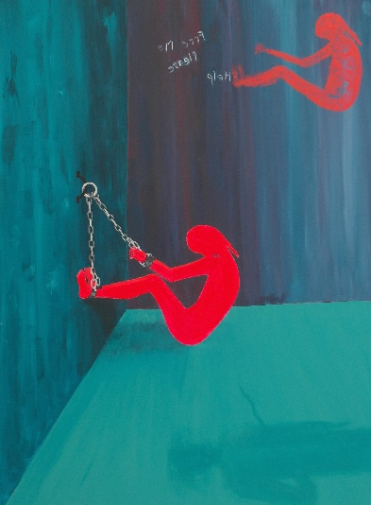
Kim Noble
I am intrigued by Kim Noble’s practice as an artist as she embodies 20 different personalities of which 14 are artists. I feel she’s a great inspiration for my work as she has explores her Dissociative Identity Disorder through artistic expression allowing each individual to explore themselves on the canvas without any recollection. I will explore Kim’s 14 artistic personalities’ as I feel their individual aesthetics and processes will provide great exploration of expression.
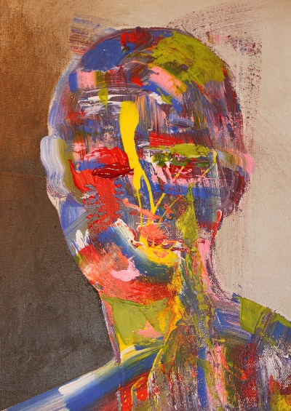
Charlie and Eddie Proudfoot
I am drawn to the Proudfoot brothers as their work emits various characteristics of emotion through colourful interpretation, I enjoy their outsider air and obscured portrait paintings as I feel they speak from a deeper, darker or more profound state. The brothers have experienced time in foster care as kids and prison and psychiatric care throughout their adult lives. I feel this source for inspiration will provide a darker take on the romanticised outlook on art and mental health.

Georgia O’Keeffe
I am interested in O’Keefe’s work as expresses herself through soft, organic oil painting though she has suffered a mental breakdown and experienced depression and anxiety, I feel inspired by Georgia’s ability to draw from the nature within herself, I have dealt with similar mental health issues, such as anxiety and insomnia, I feel utilising these memories as subjects through painting could stimulate in depth artist response work.

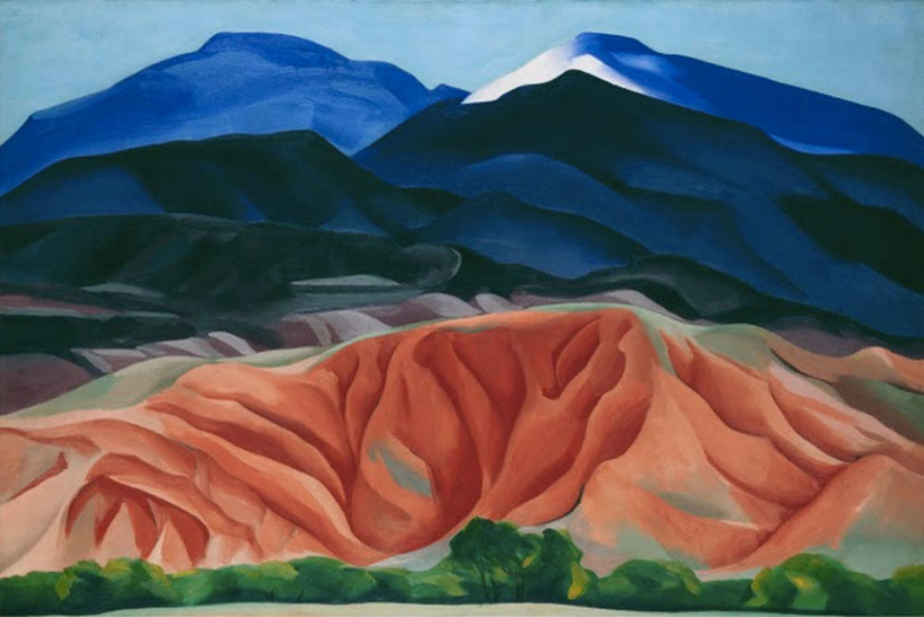

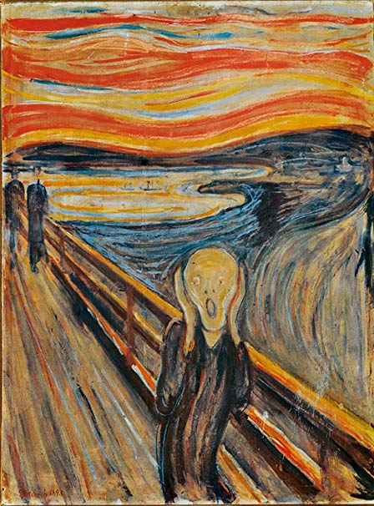
Edvard Munch
I am exploring Munch’s works as I feel his mental states read into his work, and are reflected within his artistic expression. It is apparent that Edvard Much dealt with agoraphobia, depression and had coped with mental breakdowns, he also experienced hallucinatory voices and hallucinations which have been said to inspire his famous work “The Scream”. I feel his raw works can provide a foundation for understanding established outsider art while harnessing inspiration through form colour and the mind.
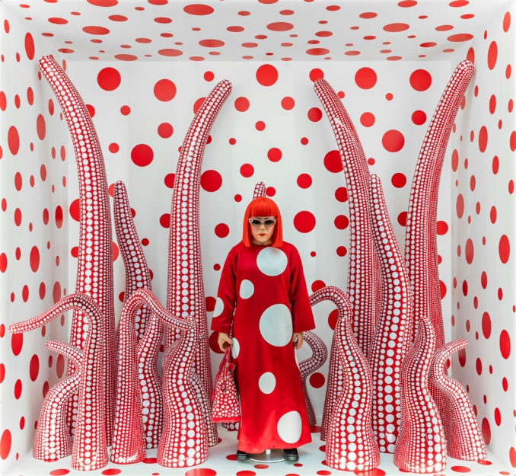
Yayoi Kusama
I am looking into Yayoi Kusama as she explores a unique perspective of art and herself, utilising her obsessional images and hallucinations as a subject for artistic form. In the 1970s, Japanese artist, Kusama voluntarily admitted herself into a psychiatric institution and currently resides there today. I am fascinated by her ability to translate mental processes authentically as an artistic medium and feel inspired to give light to the oddities of my mind, exploring shapes, figures and form through visual interpretation, to do this, I will explore patterns and textures allowing my mind and hand to outline images and locate form.

