Artist Research File – Primary Research

Liverpool Trip - Bluecoat Gallery 18.10.18

I visited Liverpool with the intention of finding a range of in-depth primary artist research, I had prepared for my trip reviewing current exhibitions on in galleries and museums online to ensure I knew what I was going for, I had found that the Liverpool Biennial 2018 was in motion around the time of my trip, commissioning over 20 artists to respond to “Beautiful world, where are you?” Inviting artists to produce works that explore societal, social and economic issues. I visited Bluecoat in particular to work from exhibitions: Time Moves Quickly, Land Sand Strand and the biennials 4TH Floor commission by Otto-Knapp, I felt this would help kick-start a body of work and inspiration.

Exhibiting: Time moves quickly by Ryan Gander
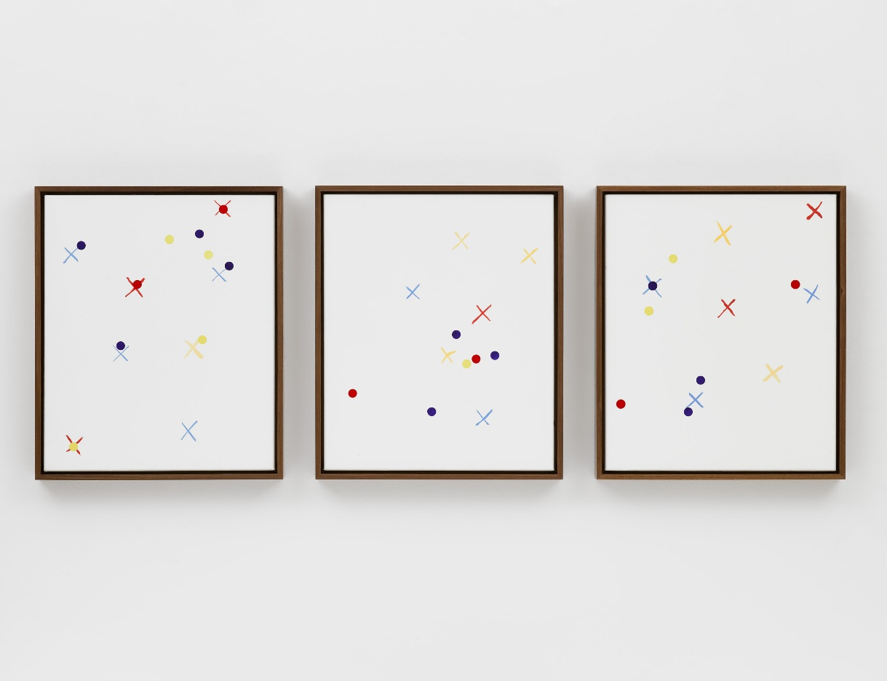

I have frequently seen Ryan Gander’s work throughout my art education and have been inspired by his simplistic yet poignant abilities in producing work through mix methods and intriguing concepts. I recently viewed Gander’s work “Time Moves Quickly” at the Bluecoat gallery in Liverpool. This major project collaborated with five children from Ash Primary School participating in workshops and producing a collection of artworks. I visited this exhibition as the project carries out inspiration taken from the Montessori Method of education, I feel this self-directed based activity and collaborative approach could hold potential inspiration towards the execution of my work and lead the way for my art therapy class.

Exhibiting: Land Sand Strand by Suki Seokyeong Kang

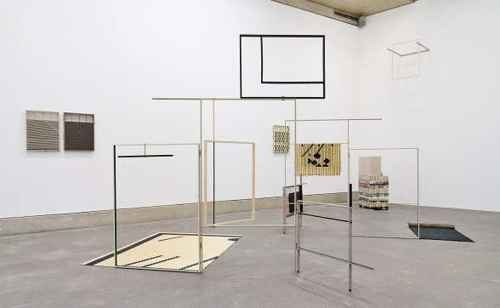

While I was at the Bluecoat I visited Suki Kang’s work. Here I found myself in a grid like environment, exhibiting geometric builds balanced in harmonic form. I was intrigued by the sense of order and structured chaos which spark my thirst for understanding what I was observing. From my understanding her installation explores the concept of space and society through an abstract multi-media environment. The use of the traditional Korean woven mat symbolises minimum space for each member in society, I found her film and installation corresponds well with my themes of identity and place, I will reference this work throughout the development of concept.
Exhibiting artist: Silke Otto-Knapp
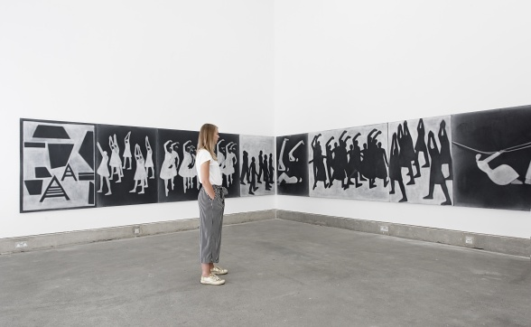

I felt gripped by Otto-Knapp’s work in the Bluecoat, I entered a room of innovative charm and movement as abstract panels of choreographed figures take centre stage through large scale visual installation. I was surprised to find out Silke’s process here was watercolour on canvas cleverly applying and removing pigment to play with depth and illusion of space. This piece was commissioned by Liverpool Biennial 2018 for the fourth-floor of the Bluecoat gallery, I was pleased to have seen this piece as I feel the exploration of form and concepts of identity, I would like to explore the concept of this piece further and respond to the work in relation to my concepts.

Liverpool Trip: Castle Fine Art 18.10.18

Featured Artist - Scarlett Raven

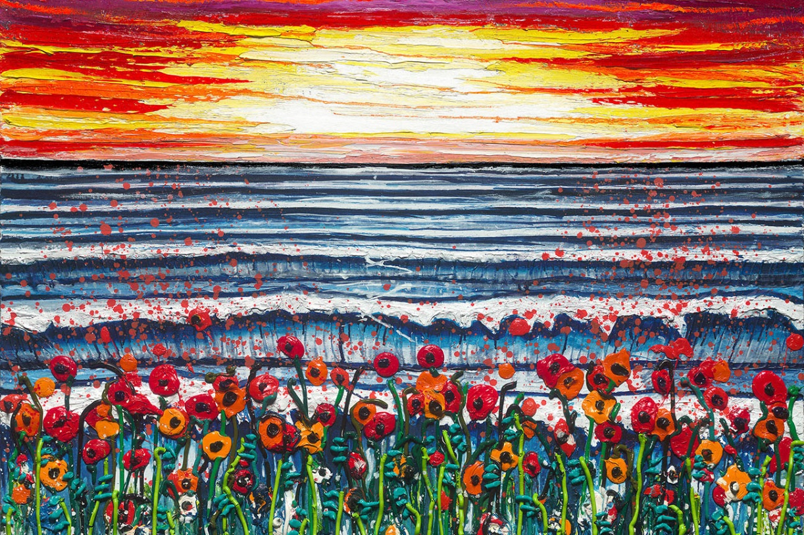

I was immediately captured by Scarlett Raven’s paintings’; her wide range of colour application, heavy texture and beautiful brush technique had my attention from outside the gallery. I was mainly drawn in by the depth of the works and vivid texture. Raven produces her paintings through movement and direction similarly to Jackson Pollock, Scarlett says “The paint is thrown on, splattered and flicked. When it lands, it captures the flowers blowing in the wind. The movement must be in every layer, so when you step back you feel like the landscape is alive. It creates a whole world of magic.” I feel inspired to involve similar methods within the development of my work, I intend on sampling her techniques of painting within the development of my contextual studies and live brief.

Castle Fine Art

Featured artist - Bob Dylan

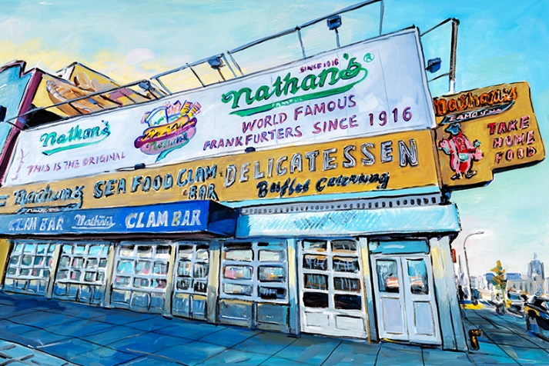

Bob Dylan’s work caught my focus through his expressive visual perspective and detail. The famed artist draws his inspiration from life stating: "I’m pretty much interested in people, histories, myth, and portraits; people of all stripes" I admire Dylan’s artwork, I feel interested in his way of presenting place by providing the viewer with a lens to his world of expression; I feel inspired to use his display of personifying place and environment through line, perspective, colour and mood, I will apply these same qualities to my work around Northenden Village.

Featuring Artist - Billy Connolly
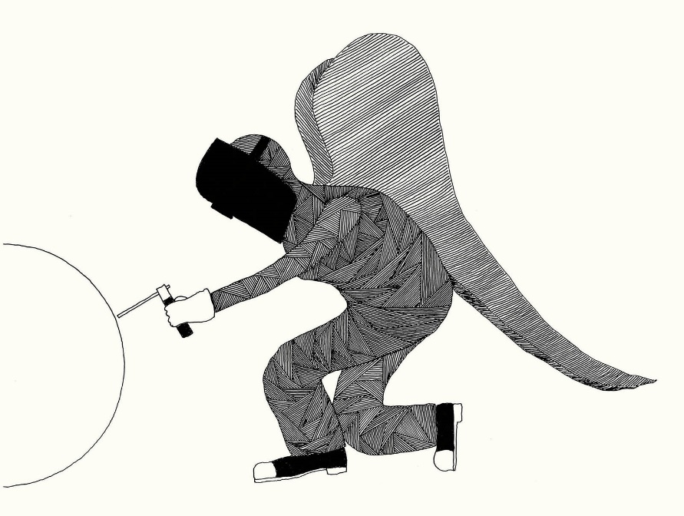

I was excited to see works of Bob Dylan and just as elevated to see the works of Billy Connolly. I was interested in his surrealist drawings; I admire the playful nature and detail in these works, Connolly’s drawing approach is similar to that of surrealist automatism (drawing from the mind). I feel I can almost compare these works to the likes of cave paintings and primal imagery in the sense that they hold a contained story through simplistic form and shape. Billy has stated ““Art, for me, bears no relation to comedy or music. My art is pure and unjudged, I am creating it for myself.” I feel inspired by his practice to apply similar understanding to my own work, I believe producing art work reveals sense of self and through this automatist approach I could begin to develop unjudged, untampered response work.

