Northenden Client: Artist research and inspiration
I searched Pinterest for imagery to form a visual mood board; collecting artworks that could give me a further idea of what style and outcome I aim to achieve. While doing this I was able note these artists and further research methods, process and concept. I found a range of interesting works and processes that could instigate depth in the development my practical work.
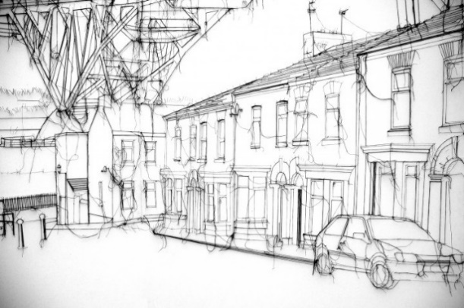
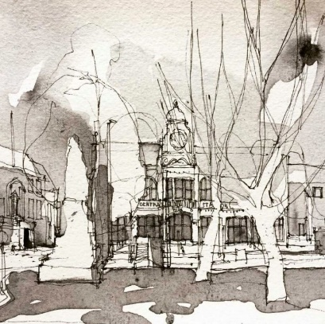
Simone Ridyard
I was interested in Ridyard’s work on Pinterest as her illustrations provoke ideas for my client’s design, I was drawn to the rough yet precise style and approach. After seeing a few images on Pinterest I looked online to further understand her perspective, she is an architect and lecturer at the Manchester school of art practicing urban drawing in the heart of my home town, Manchester. I admire the combination of pen and watercolour; I would like to apply similar application in my work balancing soft and hard mediums exploring the relationship between Northenden’s urban and rural heritage.
Debbi Smyth
I was very keen to research artist Debbie Smyth, I felt inspired by her playful approach to textiles, using pins and thread to form drawings that lift off the surface. I have used this method before and feel this process could apply an interesting dynamic to my work connecting two boards through imagery such as telegraph poles and moving cars.
Nanami Cowdroy

Here I was again drawn to the hard and soft qualities of this piece, after researching the artist Nanami Cowdroy I found this piece is the most in theme with my work as it takes from urbanised forms. Cowdroy works in surrealist design work through pen and ink processes, I feel inspired to focus on what outlines the village through similar ideas in my development work, I will produce response works exploring unique areas of the village to develop the composition of my pattern ideas.

Maija Louekari
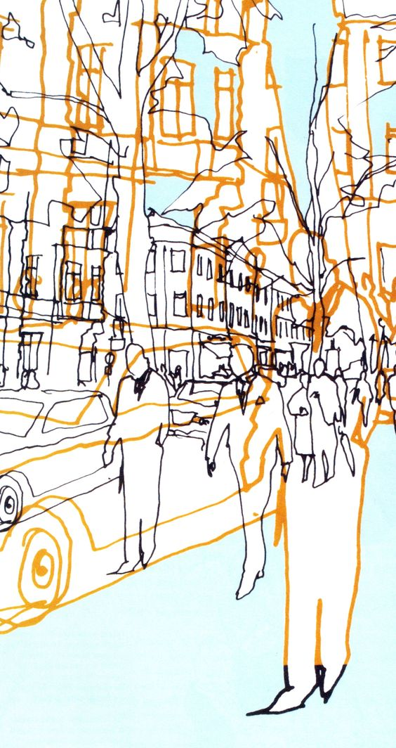
I felt inspired by this piece, I admire the repetitive nature and clever exploration of depth and form; I can feel a sense of busy urban life through simplistic line and unusual perspective. I feel these ideas could work well with my concept of Northenden’s identity highlighting abstract emotions of the village’s hustle and bustle and sense of environment. After looking into this piece I found the creator, Finnish designer Maija Louekari. Here I found out that she won a competition by producing a print in response to the moments captured in daily life at the central esplanade park in Helsinki. Her fabric takes inspiration from the sounds, feelings, environment and people that surrounded her, I am going to use this same inspiration in my approach to this competition.

